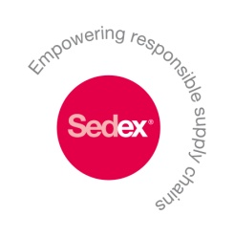

Sustainable Sourcing Guide – a Practitioner’s Guide
User Feedback Form
If you are reading and/or using this guide, please share your feedback with us. If you send useful feedback and do not wish to remain anonymous, we will gladly add your name to the list of contributors in the next version of the guide produced in 2014.
Optional information:
- First name and surname:
- Title
- Name of organization
Questions:
- How would you rate the overall usefulness and user-friendliness of this guide?
useless somewhat useful useful very useful extremely useful indispensable
- How would you rate the content of this guide?
useless somewhat useful useful very useful extremely useful indispensable
- How would you rate the form of this guide?
bad acceptable good very good extremely good excellent
- Did you find it too long, or not substantiated enough? Please explain:
- Are any crucial steps missing? Please tell us which one(s):
- Would you have liked to see more examples, or other examples? Please explain:
- Would you have liked to see more external references or tools? Which ones?
- Suggestion of additional issues, case studies or other resources.
- What would be an ideal add-on to this guide in the future?
web-based version with on-line examples, tools etc I-pad version with videos, interactive tools etc
Other, please explain:
- Have you already, or will you recommend this guide to colleagues?
yes no
- If so, to what kind of colleagues – procurement, marketing, companies, academic?
- Any other comments?
Please send this filled-in form back to info@saiplatform.org.
Thank you so much in advance for your contribution.

